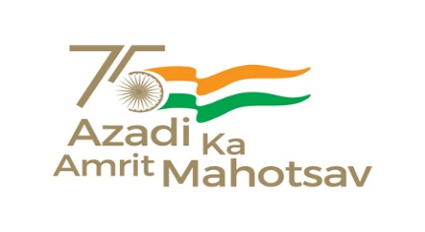
केन्द्रीय विद्यालय/KENDRIYA VIDYALAYA / सैक्टर-8, रामा कृष्णा पुरम/Sector- VIII, RK Puram
नई दिल्ली -110022 / NEW DELHI-110022
Website: rkpuramsec8.kvs.ac.in
Email: kvsector8rkp@gmail.com
Contact No. 01135100852
दिनांक : 15/06/2023
NOTICE
Registration of NON-KV students for admission in class XI (First Shift) 2023-24 is open in SCIENCE STREAM.
Registration – 16 june 2023 to 20 june 2023(on working days), Time – 10:30 A.M. to 12:30 P.M.
Documents Required.
- Registration form – (service and transfer details must be Counter signed by head of office in case of Govt. employees).
- Option form.
- Class X Marksheet (self attested).
- SC/ST/OBC/PH CERTIFICATE ( IF APPLICABLE ) Self Attested.
- Scout&Guide / NCC / Sports etc certificate (IF APPLICABLE) self attested.
- Local address proof in the name of parents (self attested).
- Aadhaar card copy of candidate (self attested).
Note:- (1). Registration form and option form can be obtained from Vidyalaya as per schedule mentioned above or it can be downloaded from Vidyalaya website from 16 june 2023.
(2). The admission process will be conducted strictly according to KVS admission guidelines: 2023-24
(3). The list of selected candidates will be displayed on Vidyalaya notice board & Vidyalaya website on 22/06/2023 at 1 P.M. (subject to availability of vacancies).
(4). Last date of documents submission of selected candidates for admission – 24/06/2023 till 1 P.M.
(5). Incomplete application will not be considered.
Link to download registration form - https://drive.google.com/file/d/1VWLkiYrOZRC-43v1xde4ibh2N0fTVSZt/view?usp=sharing

Link to download option form for first shift - https://docs.google.com/document/d/1B_Mwha5VAL26JrWaVx1dRVHft24jV7bT/edit?usp=sharing&ouid=101991516022475152513&rtpof=true&sd=true

(RABINDRA KUMAR)
PRINCIPAL

